**Building Buy Watchlists**



|  |  |  |  |  |  |  |  |
| --- | --- | --- | --- | --- | --- | --- | --- |
| Companies in **the Dow** Jones Industrial **Average** | | | | | | | |
| **Company** | **Price** | **Change** | ***'t',* Change** |  | **Price** | **Change** | % Change |
| **MMM3M** | 210.56 | -2.05 | -0.96% | INTClntel | 33.79 | -0.28 | -0.82% |
| **AXP** American Express | 83.28 | •0 32 | * 039% | JNJ Johnson & Johnson | 135.59 | -0.75 | -0.55% |
| AAPLApple | 144.51 | -1.31 | -0.90% | **JPM** JPMorgan Chase | 88.38 | •114 | +131% |
| BA Boeing | 199.06 | -0.92 | -0.46% | MCDMcDonald's | 153.98 | +0 02 | +001% |
| CAT Caterpillar | 104.39 | +0 14 | +0 13% | MRK Merel< | 65.72 | -0.20 | -0.30% |
| CVX Chevron | 104.61 | +0 47 | +045% | MSFT Microsoft | 69.44 | -1.09 | -1.55% |
| CSCOCisco | 31.93 | -0.31 | -0.96% | NKE Nike | 52.91 | -0.37 | -0.69% |
| KO Coca-Cola | 45.07 | -0.36 | -0.79% | PFE Pfizer | 33.90 | -0.14 | -0.43% |
| DIS Disney | 105.68 | +0 11 | +0 10% | PG Procter & Gamble | 88.81 | -0.55 | -0.61% |
| DD E I du Pont de Nemours and Co | 80.98 | -0.18 | -0.22% | TRV Travelers Companies Inc | 127.58 | -0.37 | -0.29% |
| **XOM** Exxon Mobil | 81.38 | +0 14 | +0 **17'!b** | UTX United Technologies | 121.78 | -0.09 | -0.07% |
| GE General Electric | 27.30 | -0.32 | -1.14% | UNH UnitedHealth | 184 64 | -0 48 | -0.26% |
| GSGoldman Sachs | 220.75 | •0 31 | **+Q 14%** | VZVenzon | 44.99 | -0.76 | -1.66% |
| HD Home Depot | 152.58 | •116 | •0 77% | vv,sa | 9509 | -0.13 | -0.14% |
| **IBMIBM** | 155 10 | -013 | -009% | WMTWal-Mart | 76 09 | +O 59 | •0 78% |

You can make all the stock trades you need from just the dow jones stocks, avoid VZ GE and KO even microsoft and intel at the time of this recording

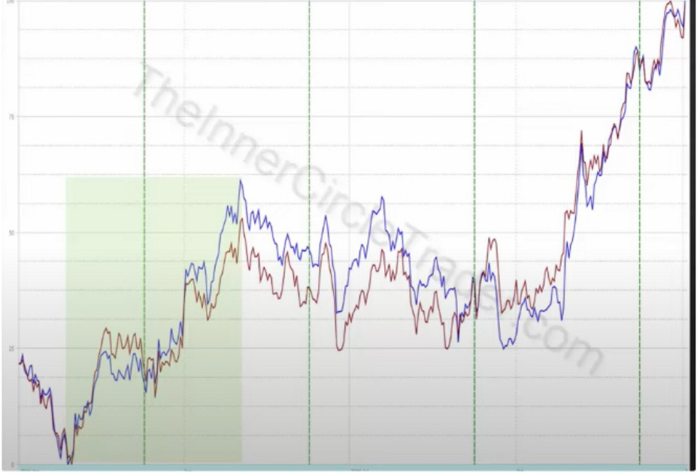We focus on buying in the first half of the year and the 2nd half of the year

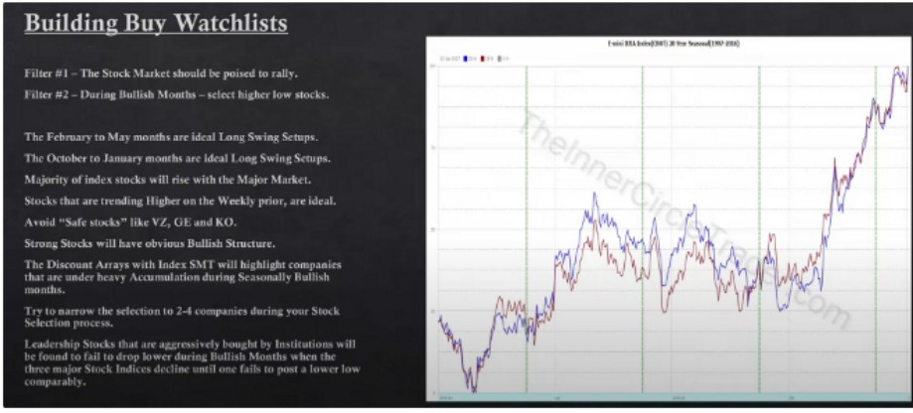

Higher low stocks means stocks that make a higher low

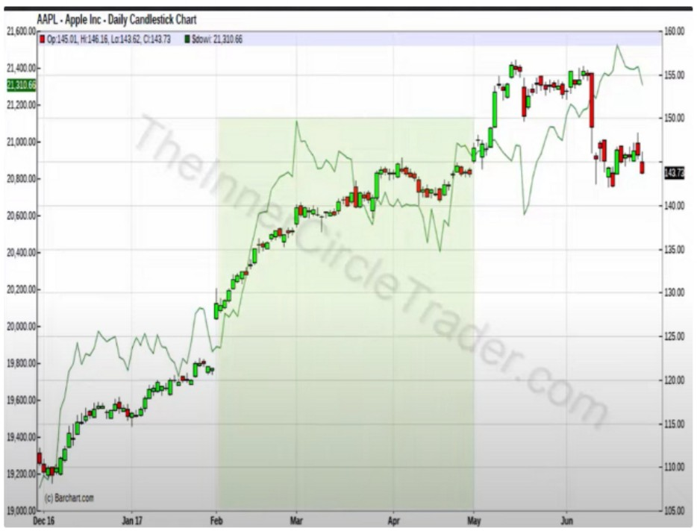

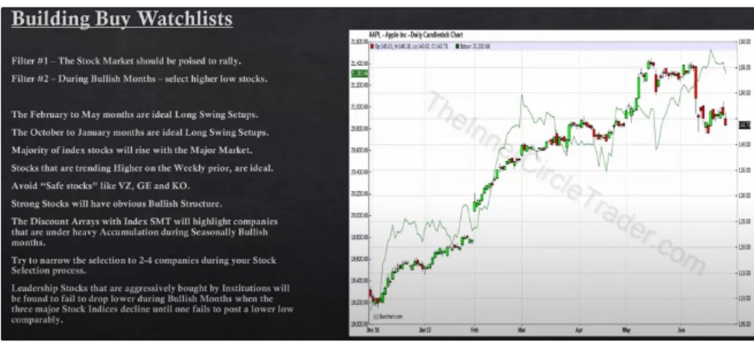

Apple failed to make a lower low and the DOW made a lower low, this confirms the relative strength

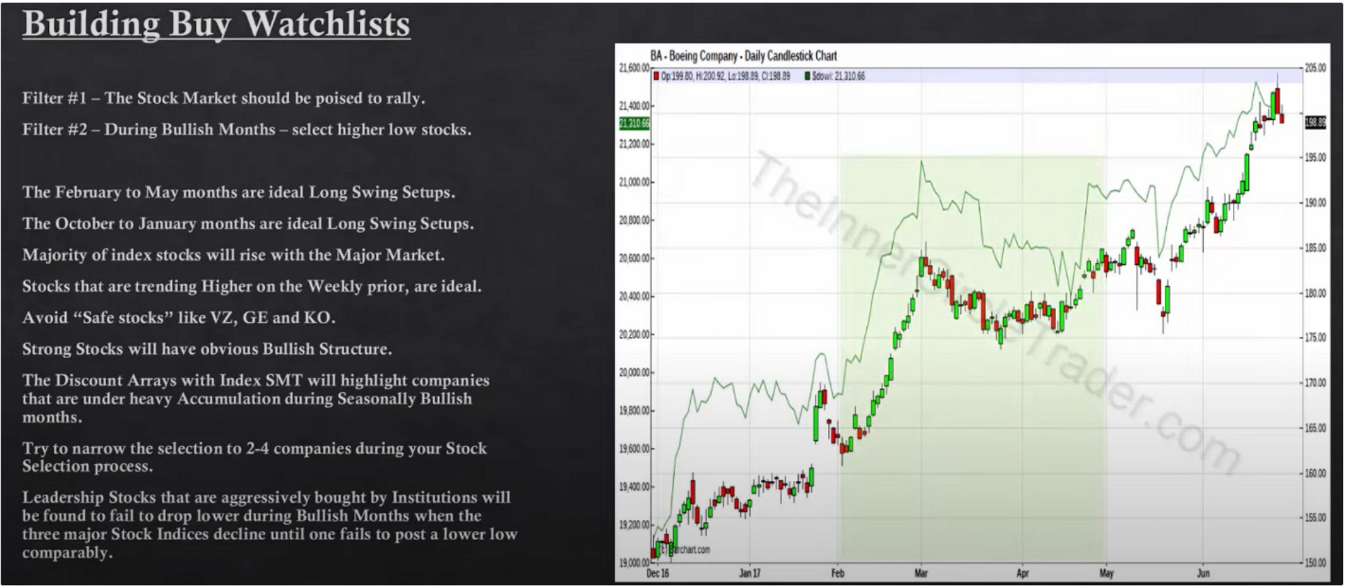

If the banks expect february to be bullish then they will buy early

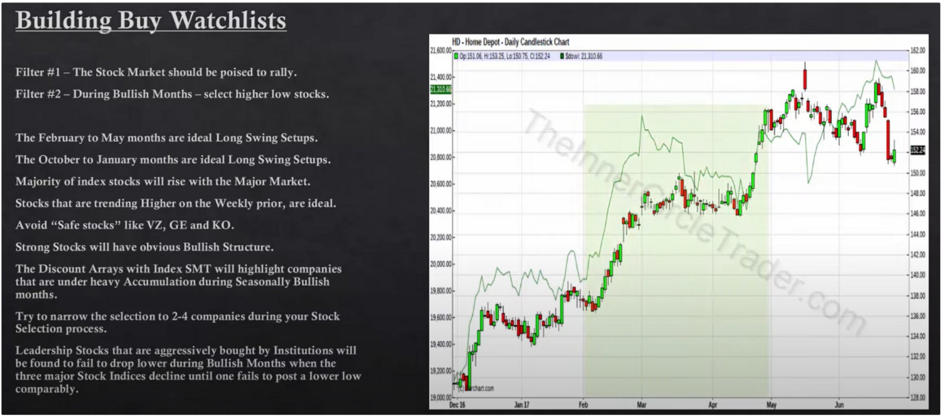

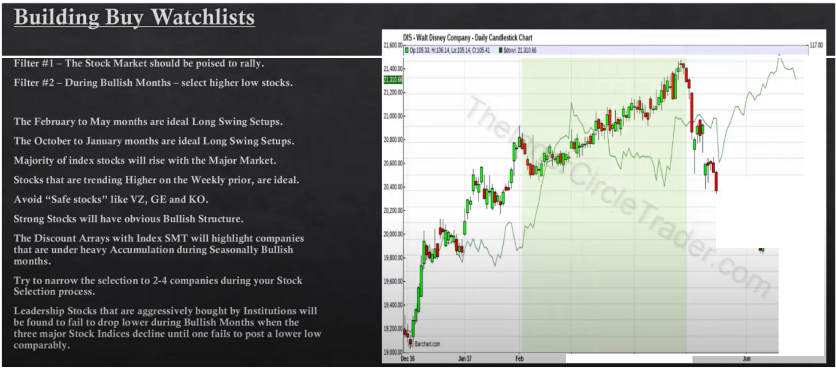

* **Ulm**

**uso,**

**111111**

**-wm**

* **Ulm**

**-wm**

**U.HI**

·IIH

1i�1

**f r**

**•!Olm**

**·IH**

**r**

**•l!H**

**•!Olm**-

**-mm**

**·IH**

..

..

**. .,m**

**. .,,m**

**•H H**

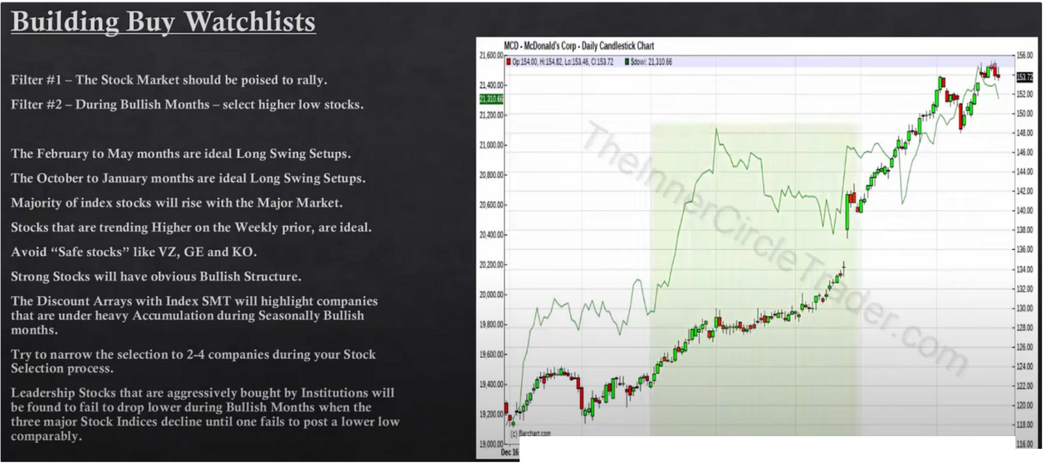

JIIIIU

---

ftl

11W

... ..



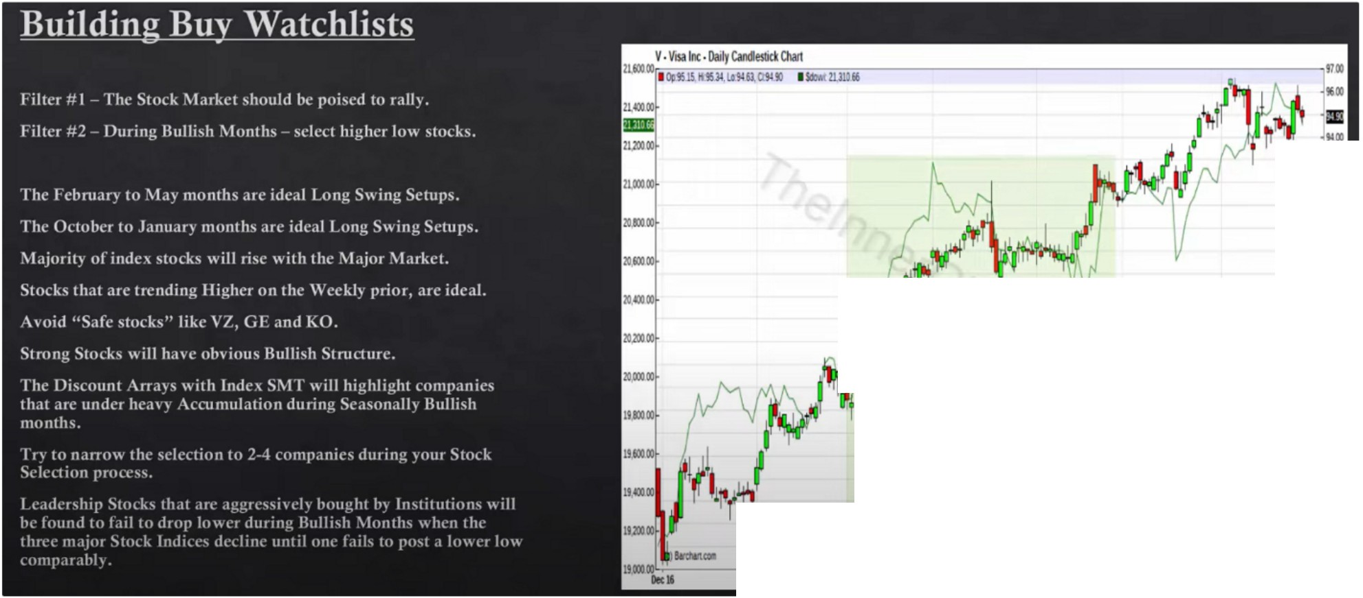

•I

lam

J.m

i::

**am i,m nm**

**H**

■**m**

**H**

I

""

·::

**jam**

12m

**-nm**

·"

..

,;

... ..

...

j

**•m**

*nm*

**•m am**

Combine it with fundamentals, major market analysis and seasonal tendency

If you have a market structure high thats really higher then where youre going to be entering at then generally that will be lethargic price action, it might peter a little bit but generally it will go sideways or even reverse

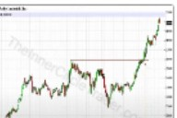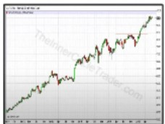]

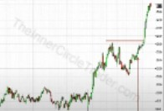

Not a good candidate

You can do this for NAS and SP as well, its going to take a little longer tho

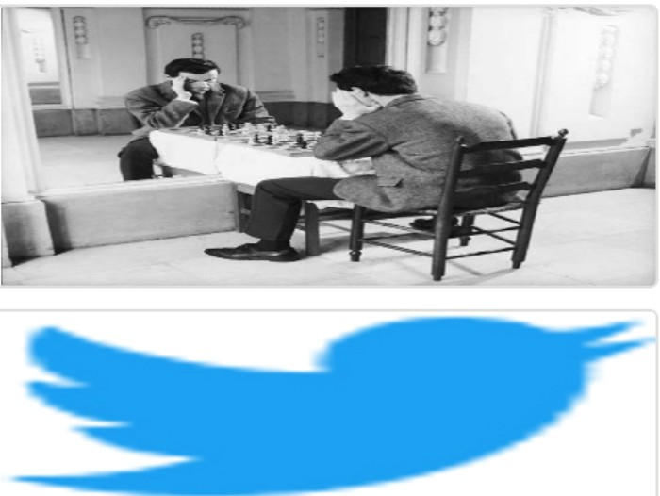Arjo I Twitter, lnstagram I Linktree

Linktree. Make your link do more. https://t.co/HhmmTN1fUI

JavaScript is not available.

*"'JI* https://twitter.com/arjoio